**MS EXCEL**:

MS Excel is a Microsoft Office application developed by Microsoft. The Excel Spreadsheet Software supports multiple operating systems such as Windows, Mac OS, Android, Ios, and iPad OS. It is used to perform calculations and computations using various functions and formulas present in Excel. We can store and analyze the data whenever it is needed.

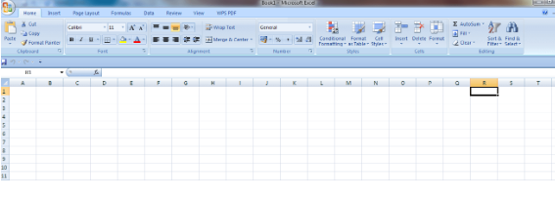

Figure 1: MS Excel Application

Cell: The intersection of rows and columns. It is present in the form of a rectangular shape. The combination of rows and columns forms a table.

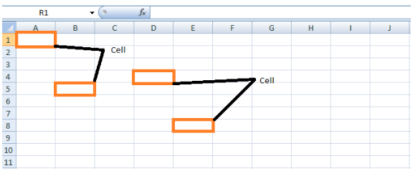

Figure 2: CELL Define

Features of MS Excel : The several features in MS Excel format and edit the data based on the requirement.

* Home: The Home option consists of tabs such as Clipboard, Font, Alignment, Number, Styles, Cells, and Editing.
* Insert: The Insert tab consists of Tables, Illustrations, Charts, Links, and Text.
* Page Lawet: Themes, Page Setup, Page Background, Paragraph, and Arrange.
* Formulas: The Formulas consist of Function Library, Defined Names, Formula Auditing and Calculation
* Data: The Data consists of Get External Data, Connections, Sort &Filter, Data Tools, and Outline.
* Review: The review tab consists of Proofing, Comments, and Changes.
* View: The View tab consists of Workbook Views, Show/Hide, Zoom, Window, and Macros.
* WPS PDF consists of Create PDF, WPS PDF Tools, and Settings.



Figure 3: Feature of MS Excel

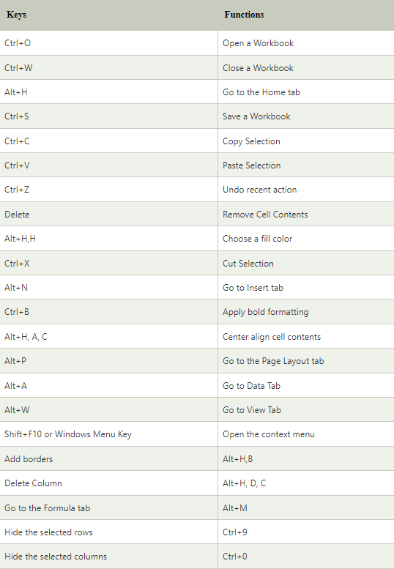

Figure 4: Shortcut Keys Using In Excel

* Functions: The functions contain familiar names and eliminate the need to enter complex formulas manually. In Excel, the formulas may contain one or more functions in the equation. Since the functions are typically another form of formulas in Excel, they also start with an equal sign (=).

**SUM:** The SUM function in Excel helps us add two or more values directly in an Excel cell. Additionally, we can also pass the cell references, ranges, or the mix of arguments. The SUM function is the most basic built-in Excel function and requires at least one argument.

The syntax of the SUM function is defined as below:

=SUM(number1, [number2], ...)

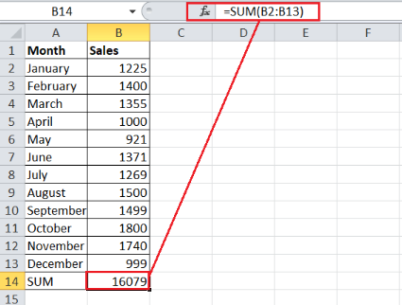

Figure 5: SUM Function

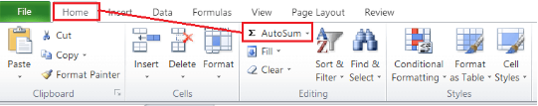

Figure 6: AutoSum

**AVERAGE:** The AVERAGE function in Excel is another basic function that is often used by beginners, especially when learning the concepts of Excel functions and applying them within the worksheet. As the name suggests, the function helps us calculate the average value or arithmetic mean for the given numbers.

The syntax of the AVERAGE function is defined as below:

=AVERAGE(number1, [number2], ...)

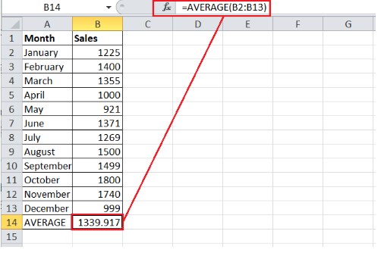

Figure 7: Average Function

**COUNT:** The COUNT function in Excel is another essential function used to count the total number of cells in a given range that contains numeric values. Using the COUNT function, we quickly know about the number/ count of numeric values (numbers) entries. The COUNT function usually ignores data sets other than numbers.

The syntax of the COUNT function is defined as below:  
=COUNT(value1, [value2], ...)

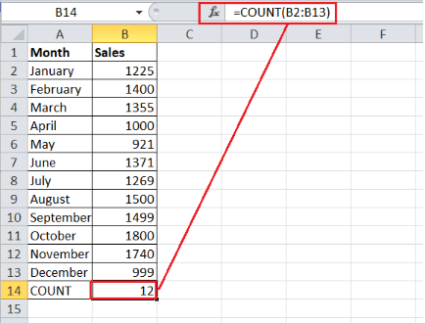

Figure 8: COUNT Function

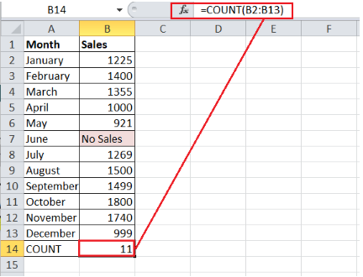

Figure 9: COUNT WHEN TEXT VALUE IS PRESENT

**MAX & MIN**: Both functions have almost the opposite operations. The MAX function helps us get the maximum value in a given set of data, cells, or ranges. In contrast, the MIN function helps us get the minimum value in a specific range. However, the syntax and the application process of MAX and MIN functions are similar.

The syntax of the MAX function is defined as below:

=MAX(number1, [number2], ...)

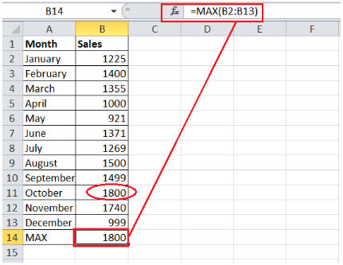

Figure 10: MAX Function

The syntax of the MIN function is defined as below:

=MIN(number1, [number2], ...)

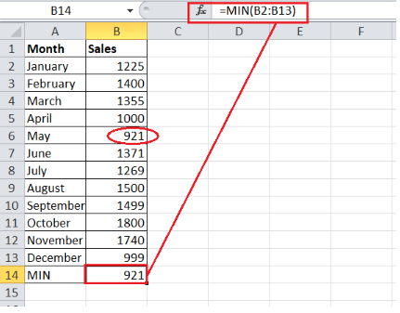

Figure 11: MIN Function

**RANDBETWEEN**: The RANDBETWEEN function in Excel lets us pick or record any random number from the given set of numbers, and it only returns a random integer number. The function is categorized under the Math and Trigonometry functions section. We need to specify a range of numbers by passing a minimum and maximum number in a formula.

The syntax of the RANDBETWEEN function is defined as below:

=RANDBETWEEN(bottom, top)

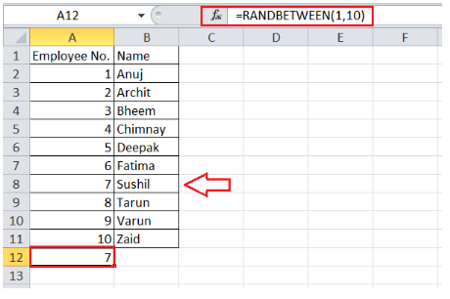

Figure 12: RANDBETWEEN Function

TRIM:

* When creating formulas in an Excel cell, we often encounter unexpected error codes instead of the expected results. The formula returns errors due to several reasons. One of the most common causes of formula errors may be the presence of unnecessary spaces in a cell. Therefore, we may need to remove such unwanted spaces in our worksheets. However, deleting the extra spaces within the large data set might be somewhat tricky if we try to check and delete them manually. This is where the TRIM function is helpful.
* Although there are multiple ways to delete extra unwanted spaces from our worksheet, the TRIM function makes it more accessible. The function eliminates all extra spaces in given cells but retains a single space character between two or more words.

The syntax of the TRIM function in Excel is defined as below:

=TRIM(text)

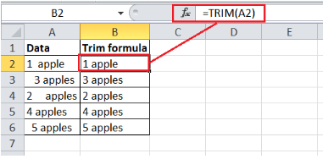

Figure 13: TRIM Function

**LEN**: The LEN function in Excel helps us know the total number of characters present in the given cell. It is essential to note that the function counts all the characters, whether numbers, text or symbols. Also, the space characters are included in the count results of the LEN function.

The syntax of the LEN function is defined as below:

=LEN(text)

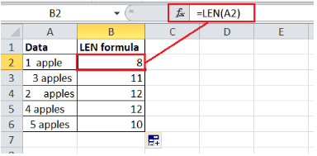

Figure 14: LEN Function

**CONCATENATE**: The CONCATENATE function in Excel helps us quickly combine values from two or more cells into a new cell.

The syntax of the CONCATENATE function is defined as below:

=CONCATENATE(text1, [text2], ?)

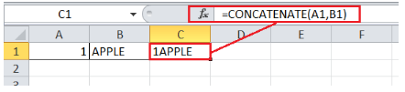

Figure 15: CONCATENATE Funtion

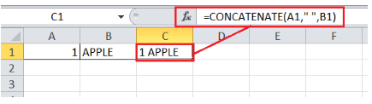

Figure 16: CONCATENATE Function with spacing

**TODAY & NOW**: In Excel, the TODAY and NOW are two different functions where the TODAY function helps us return the current date while the NOW function returns the current time and time both. Both functions are helpful if we don't remember the date or time but need to use them within the Excel cells. The beauty of these two functions is that we don't even need to pass any arguments in them.

We can use the syntax of TODAY and NOW functions in the following ways, respectively:

=TODAY( )

=NOW( )

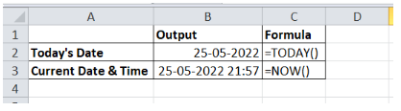

Figure 17: TODAY & NOW Function

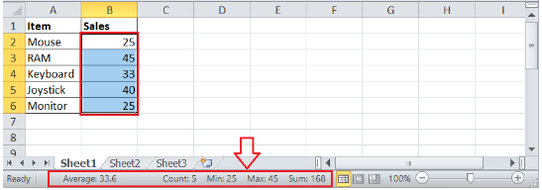

Figure 18: Image shows the AVERAGE, COUNT, MINIMUM, MAXIMUM, and SUM for the selected range of cells.

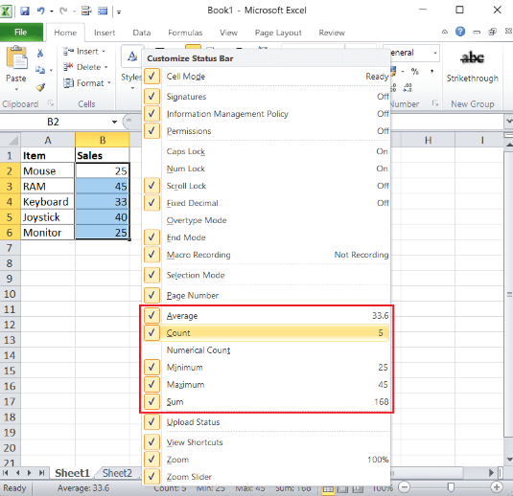

Figure 19: Tick mark/Symbol appears when we select a function to add to our status bar.

* Formula:

1. Concatenate

When conducting data analysis, the formula =CONCATENATE is one of the simplest to understand but most powerful. Text, numbers, dates, and other data from numerous cells can be combined into a single cell.

SYNTAX = CONCATENATE (text1, text2, [text3], …)

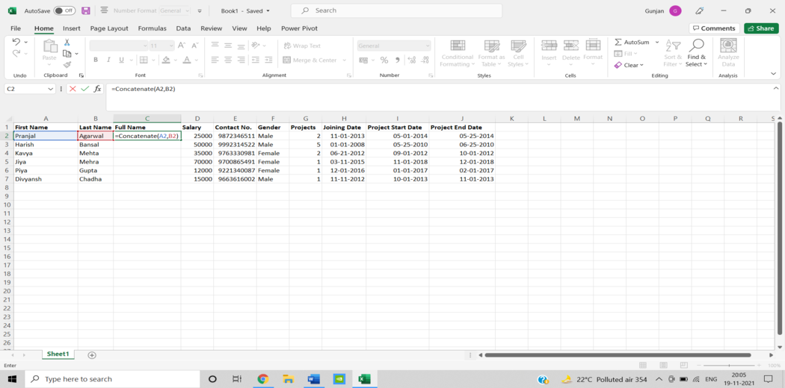

2. Len ()

In data analysis, LEN is used to show the number of characters in each cell. It’s frequently utilised when working with text that has a character limit or when attempting to distinguish between product numbers.

SYNTAX = LEN (text)

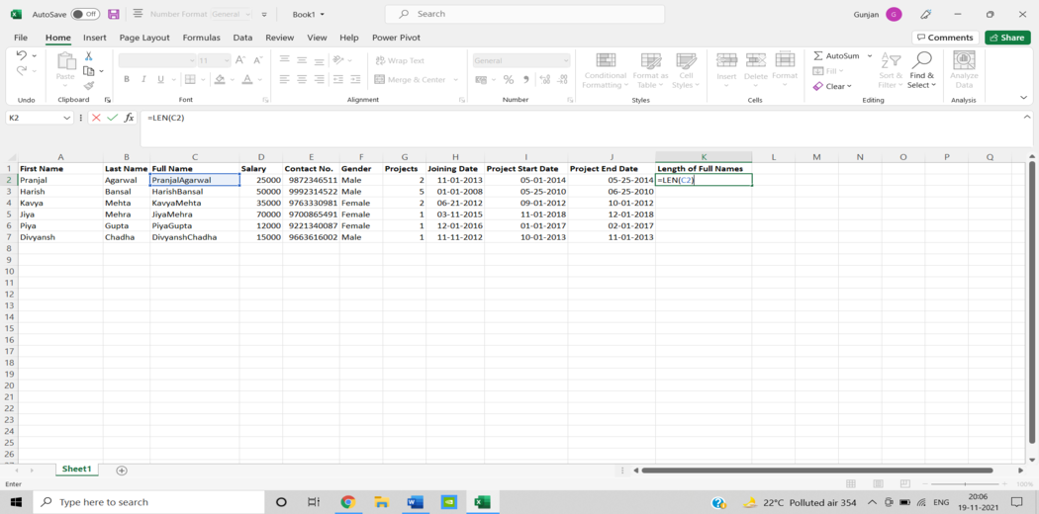

3. Days ()

The number of calendar days between two dates is calculated using this function = DAYS.

SYNTAX =DAYS (end_date, start_date)

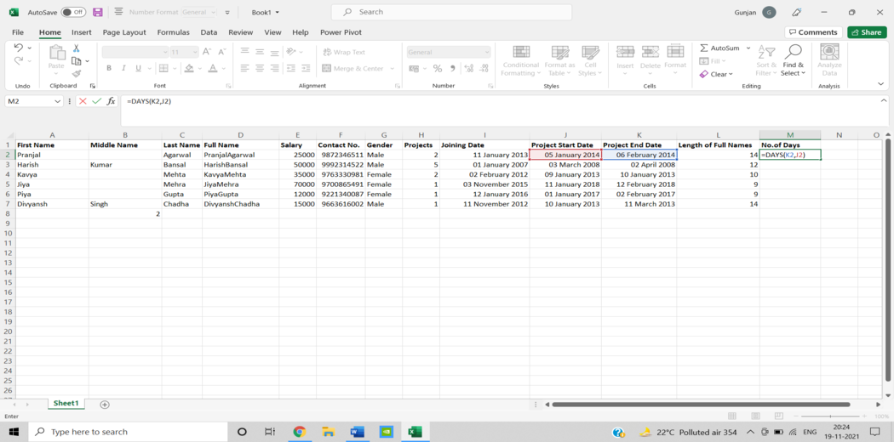

4. Networkdays

The number of weekends is automatically excluded when using the function. It’s classified as a Date/Time Function in Excel. The net workday’s function is used in finance and accounting for determining employee benefits based on days worked, the number of working days available throughout a project, or the number of business days required to resolve a customer problem, among other things.

SYNTAX = NETWORKDAYS (start_date, end_date, [holidays])

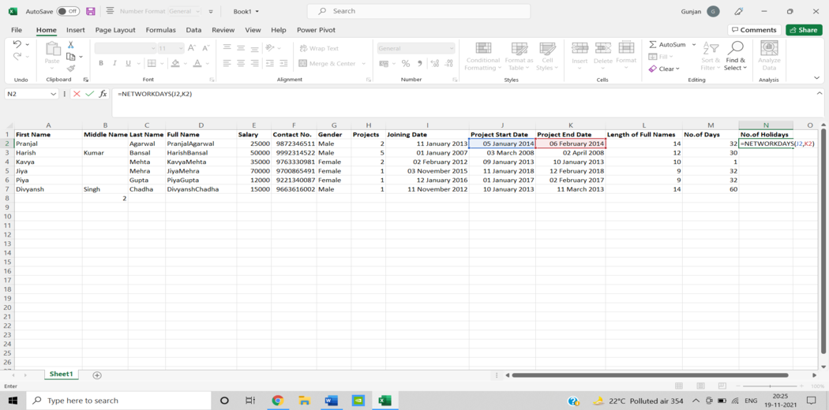

5. Sumifs()

One of the “must-know” formulas for a data analyst is =SUMIFS. =SUM is a familiar formula, but what if we need to sum data based on numerous criteria? It’s SUMIFS.

SYNTAX = SUMIFS (sum_range, range1, criteria1, [range2], [criteria2], …)

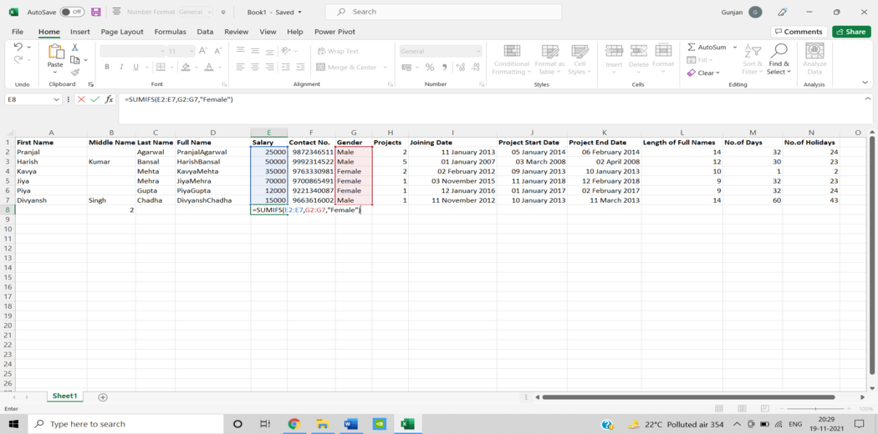

6. Averageifs()

AVERAGEIFS, like SUMIFS, lets we take an average based on one or more parameters.

SYNTAX = AVERAGEIFS (avg_rng, range1, criteria1, [range2], [criteria2], …)

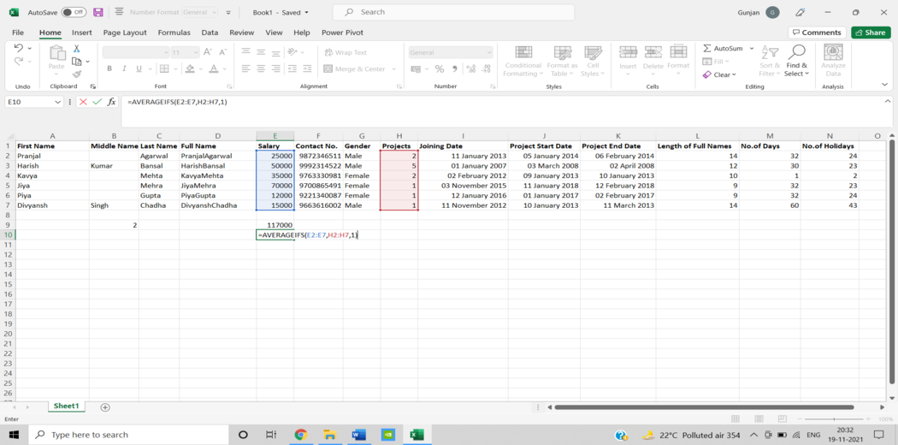

7. Countsifs()

The COUNTIFS function is yet another powerful Excel data analysis tool. It’s a lot like the SUMIFS function. The COUNTIFS function counts the number of values that satisfy a set of conditions. As a result, it doesn’t need a sum range like SUMIFS.

SYNTAX = COUNTIFS (range, criteria)

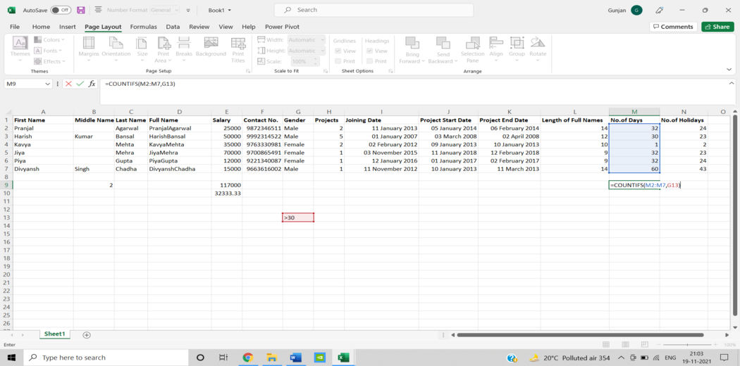

8. Counta()

COUNTA determines whether a cell is empty or not. We’ll come across incomplete data sets daily as a data analyst. Without needing to restructure the data, COUNTA will allow we to examine any gaps in the dataset.

SYNTAX = COUNTA (value1, [value2], …)

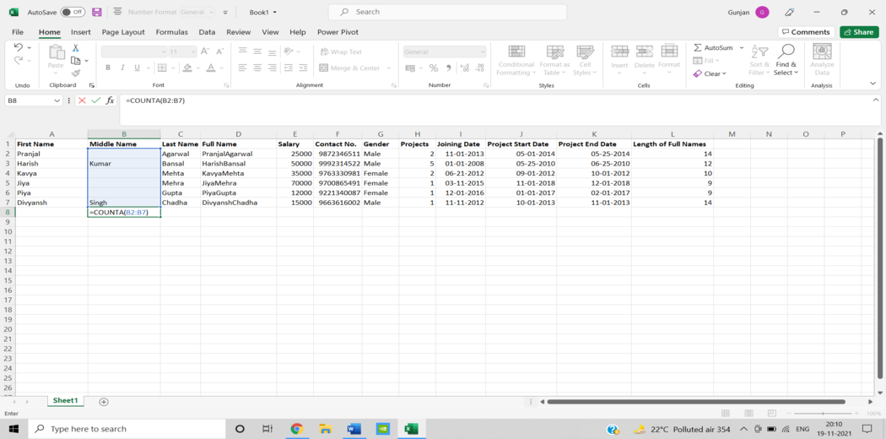

9.Vlookup()

The acronym VLOOKUP stands for ‘Vertical Lookup.’ It’s a function that tells Excel to look for a specific value in a column (the

so-called ‘table array’) to return a value from another column in the same row.

SYNTAX = VLOOKUP (lookup_value, table_array, column_index_num, [range_lookup])

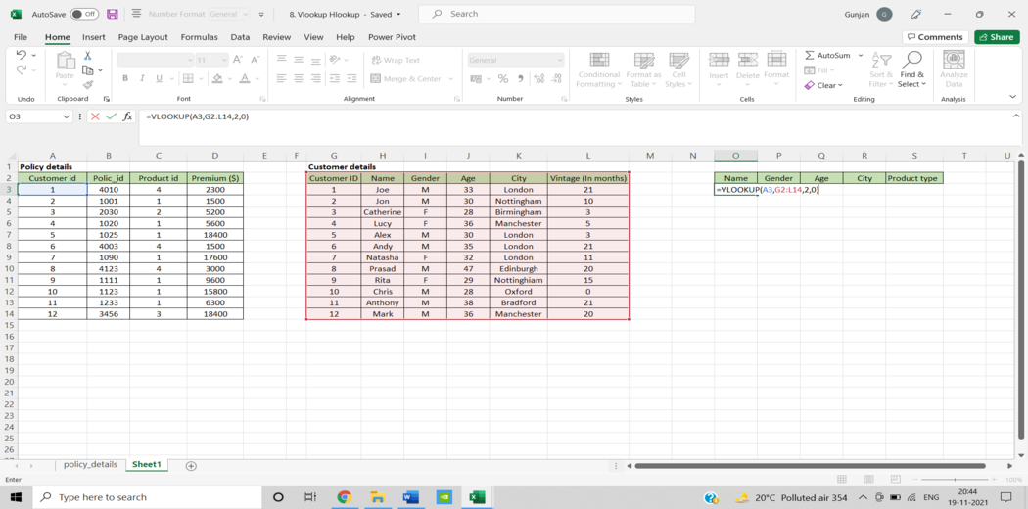

10. Hlookup()

“Horizontal” is represented by the letter H in HLOOKUP. It looks for a value in the top row of a table or an array of values, then returns a value from a row we specify in the table or array in the same column. When our comparison values are in a row across the top of a data table and we wish to look down a specific number of rows, use HLOOKUP. When our comparison values are in a column to the left of the data we wish to find, use VLOOKUP.

SYNTAX = HLOOKUP (lookup_value, table_array, row_index, [range_lookup])

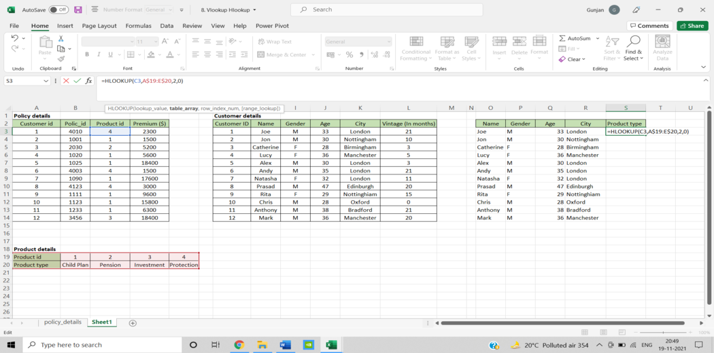

11. If ()

The IF function comes in handy a lot. We can use this function to automate decision-making in our spreadsheets. We could use IF to make Excel conduct a different computation or show a different value based on the results of a logical test (a decision). The IF function will ask we to run a logical test, as well as what action to take if the test is true and what action to take if the test is false.

SYNTAX = IF (logical_test, [value_if_true], [value_if_false])

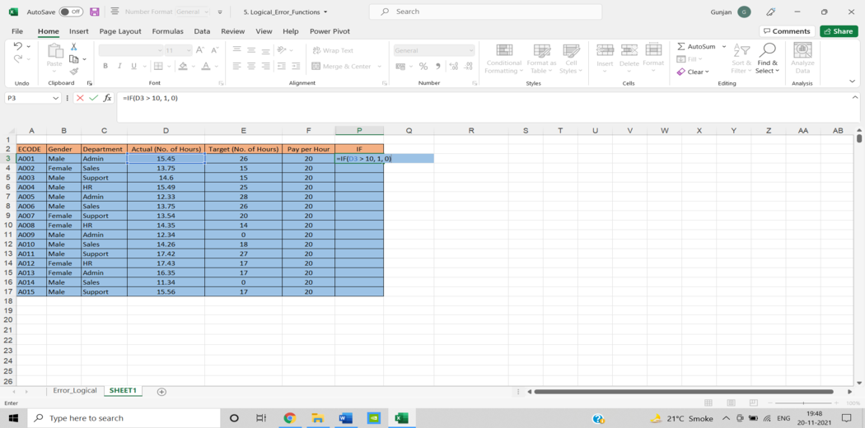

12. Iferror()

We could display a more informative error than Excel does, or even execute an alternative computation, by using IFERROR. Two things are required for the IFERROR function to work. What value should be checked for an error and what action should be taken instead.

SYNTAX = IFERROR (value, value_if_error)

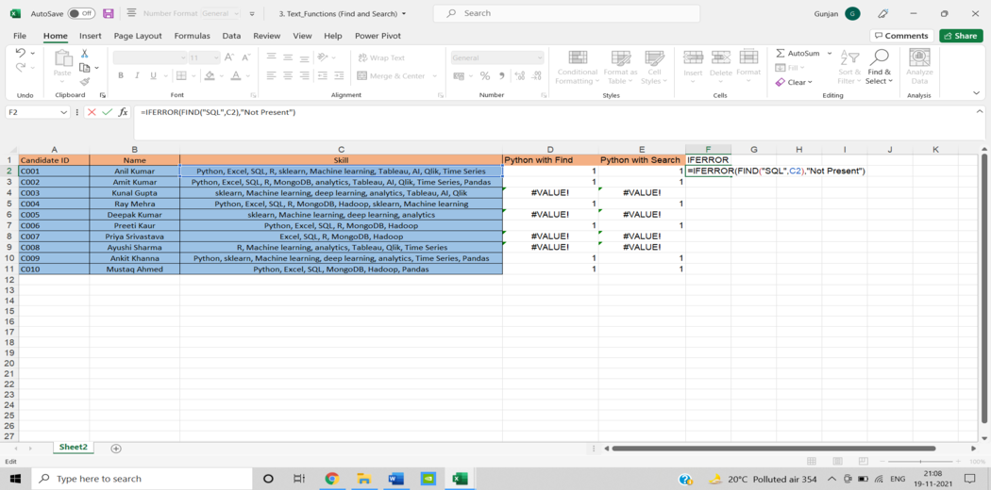

13. Find/Search

The FIND function in Excel returns the position of one text string within another (as a number). FIND delivers a #VALUE error if the text cannot be located.

However, a =SEARCH for “Bigger” will return results for Bigger or bigger, broadening the scope of the query. This is very helpful when searching for anomalies or unique identifiers.

SYNTAX = FIND (find_text, within_text, [start_num])

SYNTAX = SEARCH (find_text, within_text, [start_num])

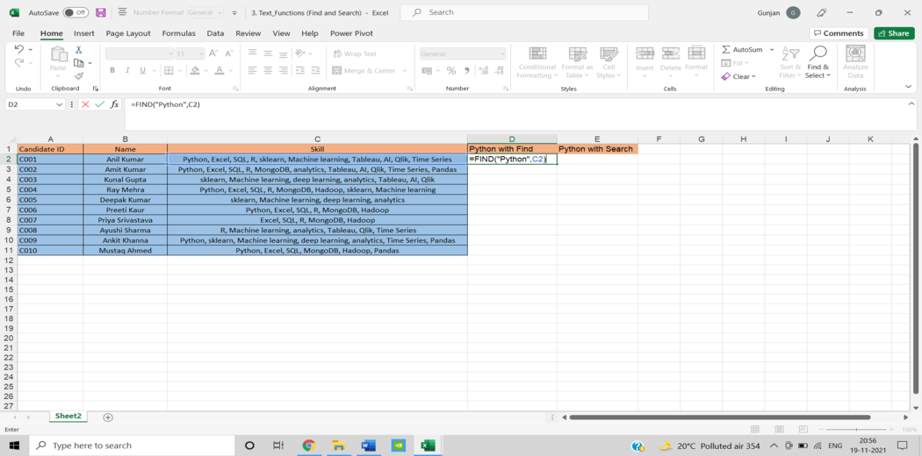

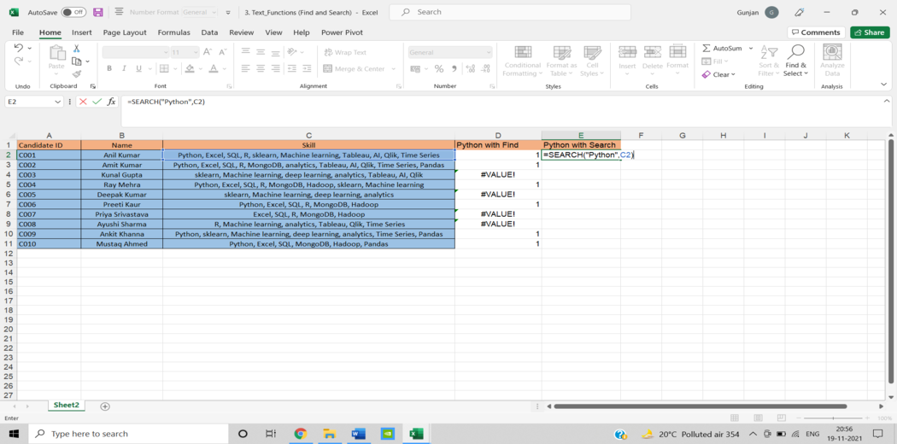

14. Left/Right

=LEFT and =RIGHT are simple and efficient ways for retrieving static data from cells. =RIGHT returns the “x” number of characters from the cell’s end, while =LEFT returns the “x” number of characters from the cell’s beginning. In the sample below, the consumer’s area code is extracted from their phone number using =LEFT, while the last four digits are extracted using =RIGHT.

SYNTAX = LEFT (text, [num_chars])

SYNTAX = RIGHT (text, [num_chars])

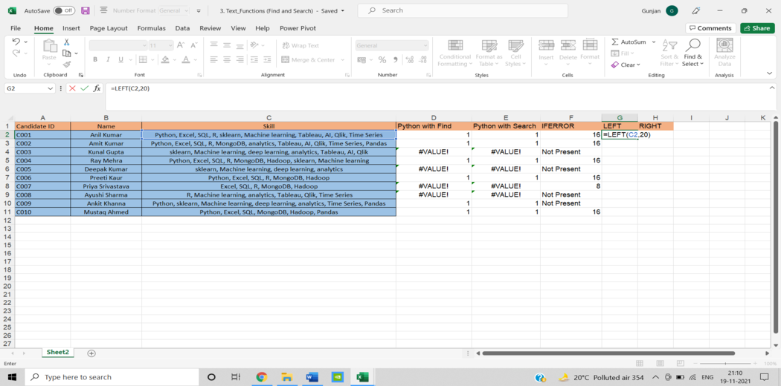

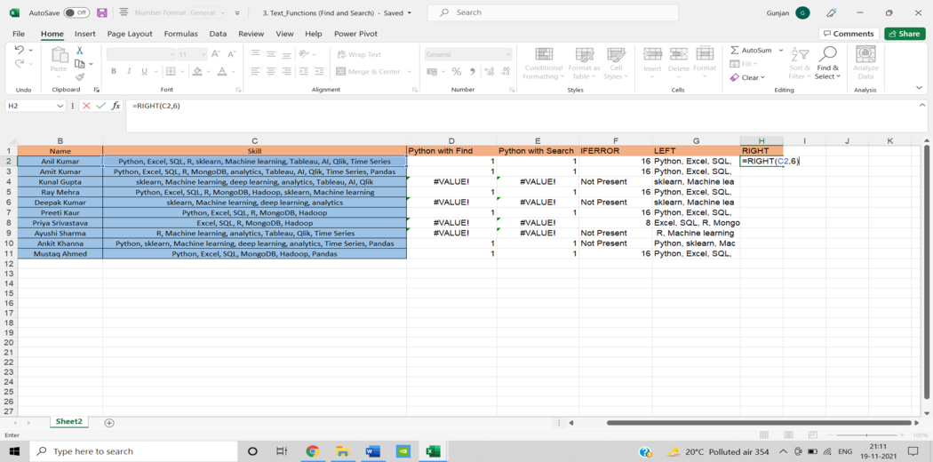

15. Rank()

Even though =RANK is an old Excel function, it is nevertheless useful for data analysis. =RANK is a quick way to show how values in a dataset rank in ascending or descending order. RANK is being utilised in this case to determine which clients order the most stuff.

SYNTAX = RANK (number, ref, [order])

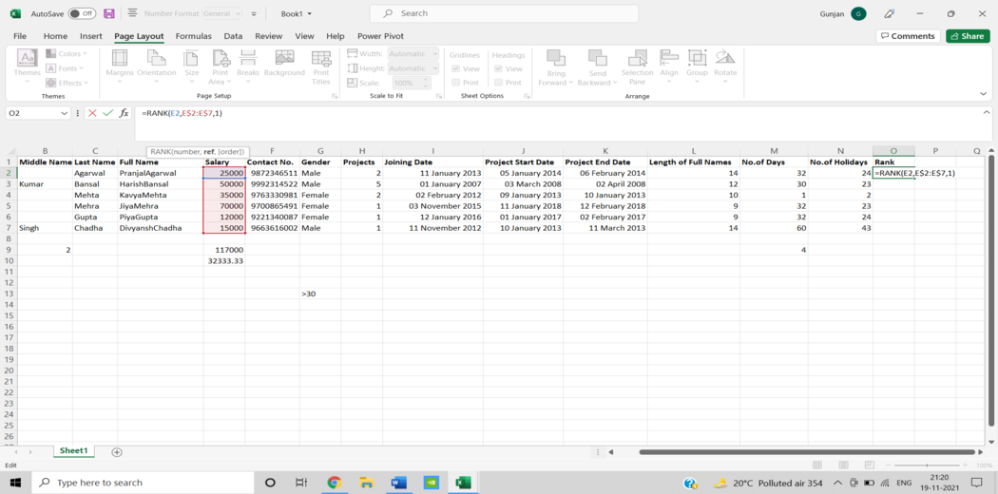

* Charts :

Step 1: Select the data for which we want to create a chart.

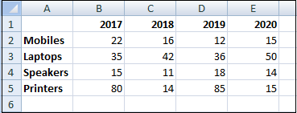

Step 2: Click on the Insert tab and go on the recommended Charts option.

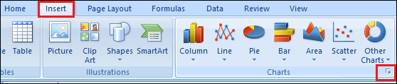

Step 3: Select the chart type according to our data and click on the Ok button.

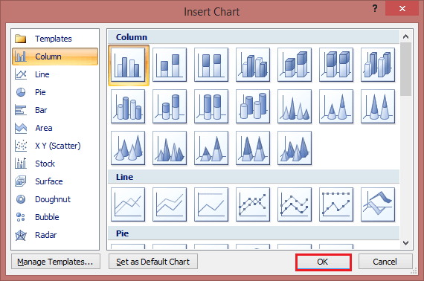

Step 4: Use the Chart Elements, Chart Styles, and Chart Filters buttons next to the upper-right corner of the chart to add chart elements like axis titles or data labels, customize the look of our chart, or change the data is shown in the chart.

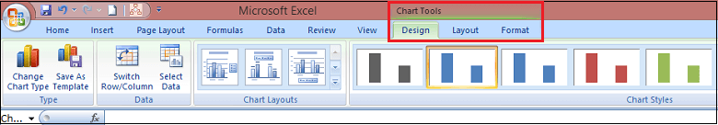

Types of Excel Charts:

1. Column Chart:

* + The column chart is the most commonly used chart. It is best used to compare information or have multiple categories of one variable, for example, multiple products or genres.
  + A Column Chart typically displays the categories along the horizontal axis and values along the vertical axis. To create a column chart, arrange the data in columns or rows on the worksheet. A column chart has the following sub-types:

1. Clustered Column
2. Stacked Column
3. 100% Stacked Column
4. 3-D Clustered Column
5. 3-D Stacked Column
6. 3-D 100% Stacked Column
7. 3-D column

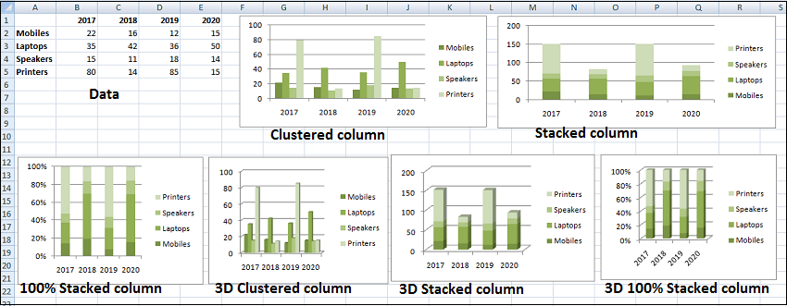

2. Line Chart:

* Line charts can show continuous data over time on an evenly scaled axis. Therefore, they are ideal for showing trends in data at equal intervals, such as months, quarters, or years. The lines connect each data point so that we can see how the values increased or decreased over a while.
  + In a Line chart, category data is distributed evenly along the horizontal axis.
  + And the value data is distributed evenly along the vertical axis.
* To create a Line chart, arrange the data in columns or rows on the worksheet. A-Line chart has the following sub-types:
  + Line
  + Stacked Line
  + 100% Stacked Line
  + Line with Markers
  + Stacked Line with Markers
  + 100% Stacked Line with Markers
  + 3-D Line charts

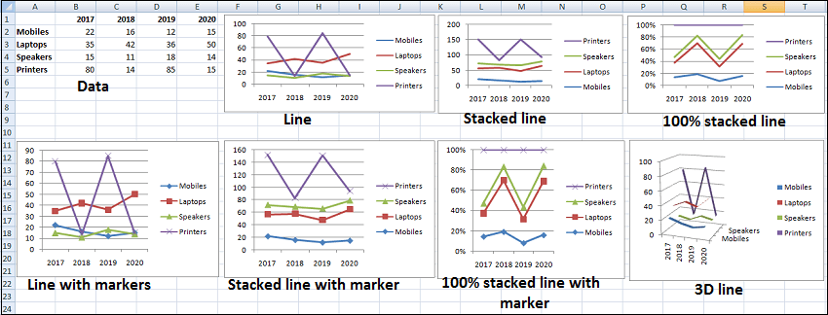

3. Pie Chart:

* Pie charts show the size of items in one data series, proportional to the sum of the items. The data points in a pie chart are shown as a percentage of the whole Pie. Each value is represented as a piece of the Pie so we can identify the proportions. To create a Pie Chart, arrange the data in one column or row on the worksheet. A Pie Chart has the following sub-types:
* Pie
* 3-D Pie
* Pie of Pie
* Bar of Pie

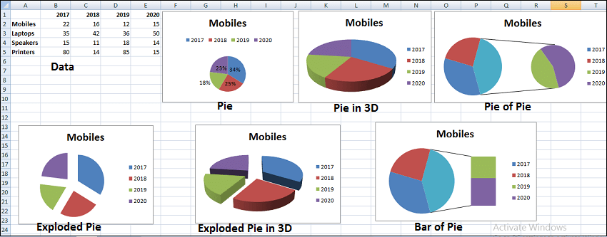

4. Doughnut Chart:

* A Doughnut chart shows the relationship of parts to a whole. It is similar to a Pie Chart, with the only difference that a Doughnut Chart can contain more than one data series, whereas a Pie Chart can contain only one data series.
* A Doughnut Chart contains rings, and each ring representing one data series. To create a Doughnut Chart, arrange the data in columns or rows on a worksheet. A Doughnut Chart has the following sub-types:
* Doughnut
* Exploded Doughnut

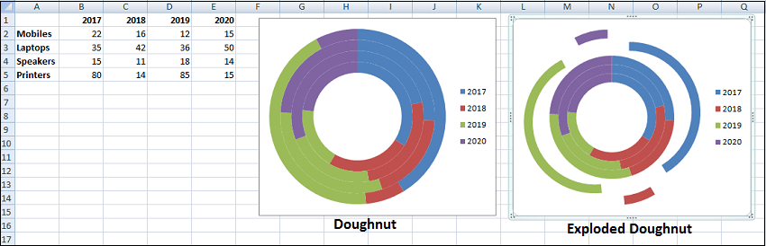

5. Bar Chart:

* Bar Charts illustrate comparisons among individual items. In a Bar Chart, the categories are organized along the vertical axis, and the values are organized along the horizontal axis.
* The main difference between bar charts and column charts is that the bars are horizontal instead of vertical. We can often use bar charts interchangeably with column charts.
* However, some prefer column charts when working with negative values because it is easier to visualize negatives vertically on a y-axis.

To create a Bar Chart, arrange the data in columns or rows on the worksheet. A Bar Chart has the following sub-types:

* Clustered Bar
* Stacked Bar
* 100% Stacked Bar
* 3-D Clustered Bar
* 3-D Stacked Bar
* 3-D 100% Stacked Bar

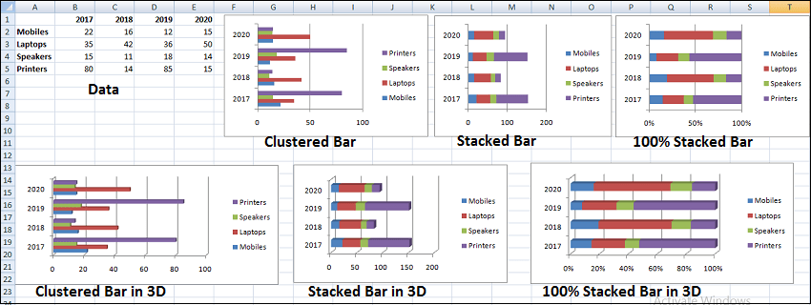

6. Area Chart:

* Area Charts can be used to plot the change over time and draw attention to the total value across a trend. By showing the sum of the plotted values, an area chart also shows the relationship of parts to a whole. To create an Area Chart, arrange the data in columns or rows on the worksheet. An Area Chart has the following sub-types:
* Area
* Stacked Area
* 100% Stacked Area
* 3-D Area
* 3-D Stacked Area
* 3-D 100% Stacked Area

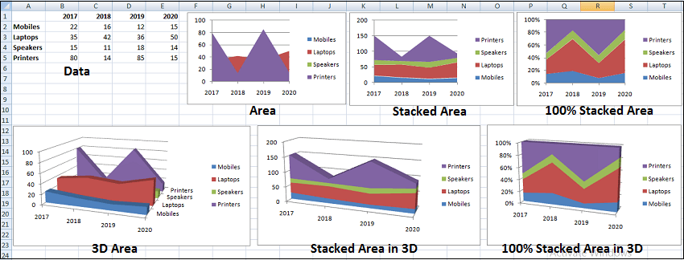

7. Stock Chart:

* As the name implies, stock charts can show fluctuations in stock prices. However, a Stock chart can also show fluctuations in other data, such as daily rainfall or annual temperatures.
* To create a Stock chart, arrange the data in columns or rows in a specific order on the worksheet. For example, to create a simple high-low-close Stock chart, arrange our data with High, Low, and Close entered as column headings, in that order. A Stock chart has the following sub-types:
* High-Low-Close
* Open-High-Low-Close
* Volume-High-Low-Close
* Volume-Open-High-Low-Close

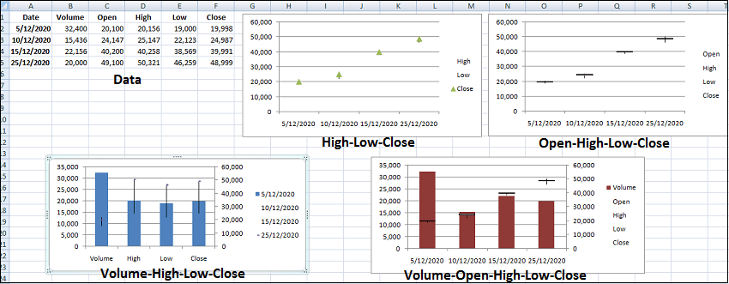

* Data Analysis Tool pack

1. Descriptive Summaries :

1. Ranges and Tables:

* The information we have can be in the form of a table or a range. Whether the data is in a range or a table, certain actions can be performed on it. Certain procedures, however, are more successful when data is stored in tables rather than ranges. There are some operations that are only applicable to tables. We will also gain an understanding of how to analyze data in ranges and tables. We’ll learn how to name ranges, how to utilise them, and how to manage them. The same may be said for table names.

2. Data Cleaning – Text Functions, Dates and Times

* Before moving on to data analysis, we must clean and organize the data we’ve gathered from multiple sources. The following approaches can be used to clean data in Excel.

1. With Text Functions
2. Containing Date Values
3. Containing Time Values

3. Conditional Formatting

* Conditional formatting instructions in Excel allow we to colour cells or fonts, as well as place symbols next to values in cells, based on predetermined criteria. This aids in visualizing the most important values.
* It allows we to highlight cells with a different colour depending on the value we set to them. Rules, data bars, colour scales, icon Sets, finding duplicates, shading alternate rows, comparing two lists, conflicting rules, checklists, and creating Heat Maps all benefit from conditional formatting.

4. Sorting and Filtering

* We may need to sort and/or filter our data to prepare for data analysis and/or to display specific critical data. We can perform the same thing in Excel using the simple sorting and filtering options. Sort and Filter are the most used Excel functions. Within columns, sorting can be done in ascending or descending order. Lists can be sorted by colour, reversed, or randomly generated. Filters are used to display data that meets requirements. Number and Text Filters, Date Filters, Advanced Filter, Data Form, Remove Duplicates, Outlining Data, and Subtotal are some of the options.

5. Subtotals with Ranges

* PivotTables are commonly used to summarize data, as we are aware. However, Subtotals with Ranges is another Excel function that allows we to group/ungroup data and summarize data in ranges in a few simple steps.

6. QuickAnalysis

* We can quickly execute numerous data analysis activities and create quick representations of the results with Excel’s Quick Analysis function.

7. Understanding Lookup Functions

* Excel Lookup Functions allow we to search through a large amount of data for data values that fit a set of criteria. Vlookup and Hlookup are two different types of lookup engines. Analysts use Vlookup and Hlookup to discover a value in a database and retrieve other values that correspond to that value. Data analysts frequently use it to integrate and consolidate useful data from several excel sheets.

8. PivotTables

* PivotTables allow we to summarise data and create dynamic reports by modifying the PivotTable’s contents. We can use pivot tables to extract important data from a vast dataset. This is the most practical method of data analysis. After inserting a Pivot Table, we can drag fields, sort, filter, or change the summary calculation. Two-dimensional Pivot Tables are also possible. Group Pivot Table Items, Multi-level Pivot Table, Frequency Distribution, Pivot Chart, Slicers, Update Pivot Table, Calculated Field/Item, and GetPivotData are all important functions.

9. Data Visualization in Excel

* Charts are simple to make and display data in a variety of ways, making them more helpful than a sheet. We can make a chart, modify its type, adjust the row or column, the legend location, and the data labels. Column Chart, Line Chart, Pie Chart, Bar Chart, Area Chart, are some of the different types of charts provided in Microsoft Excel.

10. Data Validation

* Only valid values may need to be entered into cells. Otherwise, they risk producing erroneous results. Using data validation commands, we can rapidly set up data validation values for a cell, an input message prompting the user on what should be typed in the cell, validate the values provided against the supplied criteria, and display an error message in the case of incorrect entries. It may be necessary to insert only valid values into cells. Otherwise, they could result in inaccurate calculations. We may quickly set up data validation values for a cell, an input message prompting the user on what should be typed in the cell, validate the values entered against the given criteria, and display an error message in the case of wrong entries using data validation commands.

11. Financial Analysis

* Excel has several financial features. However, we may learn to employ a combination of these functions to solve common situations that need financial analysis.

12. Working with Multiple Worksheets

* It’s possible that we’ll need to run multiple identical calculations in different worksheets. Instead of duplicating these calculations in each worksheet, we can complete them in one and have them display in all of the others. We may also use a report worksheet to compile the data from the multiple worksheets.

13. Formula Auditing

* When we utilise formulas, we should double-check that they are working correctly. Formula Auditing commands in Excel assist we in tracing previous and dependent variables as well as error checking.

14. What-if Analysis

* We can extract critical data from a large dataset using pivot tables. This form of data analysis is the most practical. We can drag fields, sort, filter, and adjust the summary calculation after a Pivot Table has been inserted. Pivot Tables can also be made in two dimensions. The functions of Group Pivot Table Items, Multi-level Pivot Table, Frequency Distribution, Pivot Chart, Slicers, Update Pivot Table, Calculated Field/Item, and GetPivotData are all essential.

1. **Correlation:**

Step one: Open Excel and start a new worksheet for our correlated variable data. Enter the data points of our first variable in column A and our second variable in column B. We can add additional variables as well in columns C, D, E, etc. — Excel will provide a correlation coefficient for each one.

In the example below, we’ve entered six rows of data in column A and six in column B.

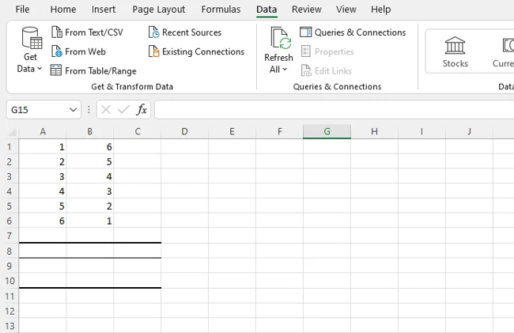

Step Two. Install the Analysis Toolpak.

Next up? If we don’t have it, install the Excel Analysis Toolpak.

Select “File”, then “Options,” and we’ll see this screen:

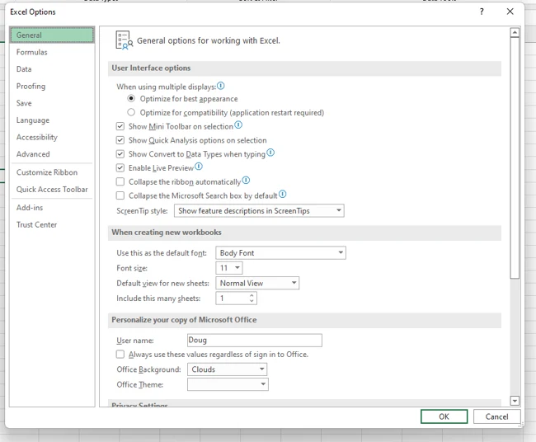

Select “Add-Ins” and then click on “Go”.

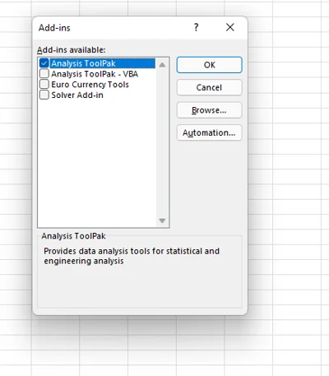

Now, check the box that says “Analysis ToolPak” and click “Ok”.

Step Three. Select “Data” from the top bar menu.

Once we have the ToolPak installed, select “Data” from the top Excel bar menu. This provides we with a submenu that contains a variety of analysis options for our data.

Step Four. Select “Data Analysis” in the top right-hand corner.

Now, look for “Data Analysis” in the top right-hand corner and click on it to get this screen:

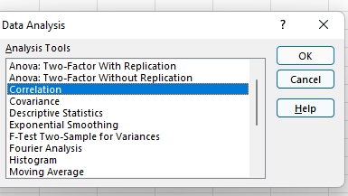

Step Five. Select Correlation.

Select Correlation from the menu and click “OK.”

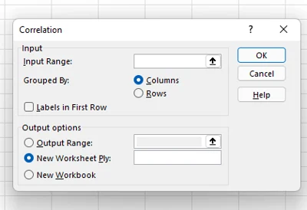

Step Six. Define our data range and output.

Now define our data range and output. We can simply left-click and drag our cursor across the data we want to select, and it will auto-populate in the Correlation box. Finally, select an output range for our correlation data — we’ve chosen A8. Then, click “Ok”.

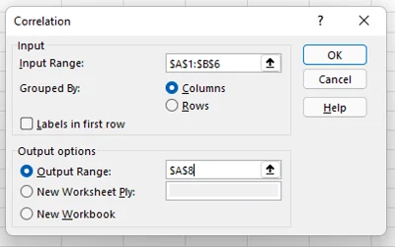

Step Seven. Evaluate our correlation coefficient.

Our correlation results will now be displayed. In our example, values in column 1 and column 2 have a perfect negative correlation; as one goes up, the other goes down at the same rate.

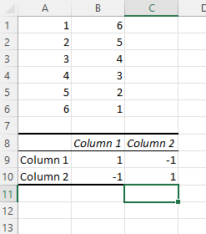

Excel correlation results are also known as an Excel correlation matrix. In the example above, our two columns of data produced a perfect correction matrix of 1 and -1. But what happens if we produce a correlation matrix with a less ideal data set?

Here’s our data:

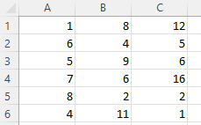

And here’s the matrix:

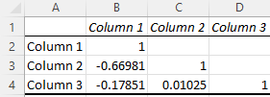

**Correlation Formula:**

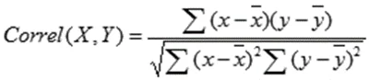

* X and Y are our measurements, ∑ is the sum, and the X and Y with the bars over them indicate the mean value of the measurements. We would calculate it as follows:
* Calculate the sum of variable X minus the mean of X.
* Calculate the sum of variable Y minus the mean of Y.
* Multiply those two results and set that number aside (this is the first result).
* Square the sum of X minus the mean of X. Square the sum of Y minus the mean of Y. Multiply those two numbers.
* Take the square root (this is the second result).
* Divide the first result by the second result.
* We get the correlation coefficient.

1. **Regression:**

We will need to have the Data Analysis add-in installed to our version of Excel to run statistical tests. If we click on the “Data” menu tab and see the “Data Analysis” option as below, then the add-in is already installed.

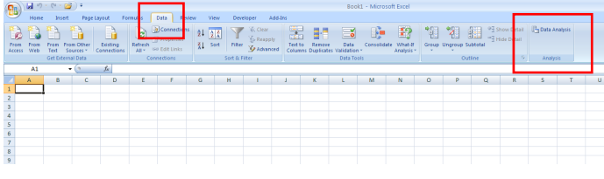

If we do not see the “Data Analysis” option, we will need to install the add-in. Depending on the version of Excel we are using, we do this by clicking on the Office button in the top left corner, and selecting the “Excel Options” button (below left), or clicking on the “File” tab and then the “options” button (below right).

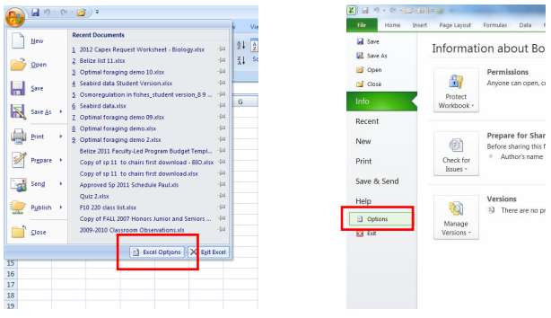

We will then see the Excel Options menu (left): click on the “Add-Ins” button and select the “Analysis ToolPak” and click the “Go” button to install. The“Data Analysis” tab should then appear in the “Data” menu as shown above

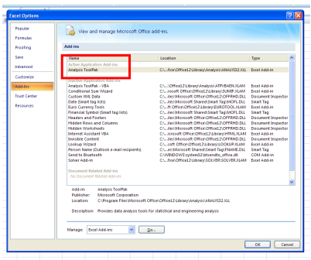

To run the regression, arrange our data in columns as seen below. Click on the “Data” menu, and then choose the “Data Analysis” tab. We will now see a window listing the various statistical tests that Excel can perform. Scroll down to find the regression option and click “OK”.

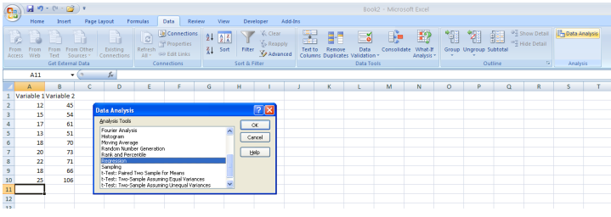

Now input the cells containing our data. In the menu box, click in the “Input Y Range” box and then use the cursor to select the column containing the data for the dependent variable. As we select the cells in our spreadsheet, the range should also appear in the menu box window. Repeat the process for “Input X Range” and our independent variable data. When everything looks good, click “OK”. We will now see the results of our statistical test (unless we selected otherwise, by default the results will open in a new worksheet).

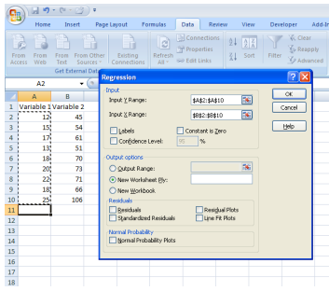

Among the variables that appear in the results sheet (left), depending on our experiment the most important result is the R square value, highlighted at left in the pink cell. We then report the R 2 value in our text when we describe our statistical results. If we include a figure showing our regression analysis, we should also include this value in the figure. Steps for doing this appear below. We can also see the p-value (in red box) indicating whether or not the test is statistically significant (i.e. if p < 0.05). In this example, the p-value is 0.00018.

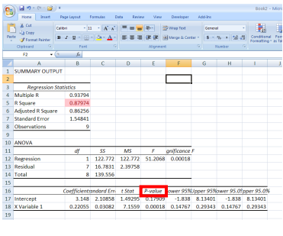

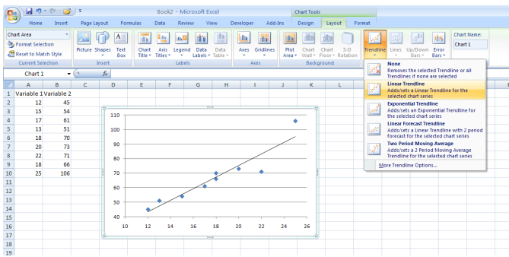

Create our regression curve by making a scatter plot. Add the regression line by choosing the “Lawet” tab in the “Chart Tools” menu. Then select “Trendline” and choose the “Linear Trendline” option, and the line will appear as shown above. To add the line equation and the R2 value to our figure, under the “Trendline” menu select “More Trendline Options” to see the “Format Trendline” window shown below. Select the boxes next to “Display equation on chart” and “Display R-squared value on chart” and we are all set. (Note that we do not need to go through the “Data Analysis” steps above to calculate our R2 value if we use this method – Excel will do that automatically).

